

22f-3104

COAL Lab 8



March 31, 2024

fast cfd campus

**Task 1:**

**Code:**

[org 0x0100]

mov ax, 0xB800 ; Video memory segment

mov es, ax ; Set ES to video memory segment

mov di, 0 ; DI points to the start of video memory

cls:

mov word [es:di], 0x0720

add di, 2

cmp di, 4000

jne cls

mov si, body

mov di, 1688

mov cx, 8

print_snake:

mov al, [si] ; Character to represent the snake

mov ah, 0x02 ; Attribute (grey on black)

mov word [es:di], ax

add di, 2

loop print_snake

mov al, [head] ; Character to represent the snake

mov ah, 0x02 ; Attribute (grey on black)

mov word [es:di], ax

add di, 1976

mov si, msg

mov cx, 18

loops:

mov al, [si] ; Character to represent the snake

mov word [es:di], ax

mov ah, 0x02 ; Attribute (grey on black)

add si, 1

add di, 2

loop loops

mov cx, 8

mov si, position

pos:

mov al, [si] ; Character to represent the snake

mov word [es:di], ax

mov ah, 0x02 ; Attribute (grey on black)

add si, 1

add di, 2

loop pos

mov cx, 16

mov si, msg2

add di, 108

lengthss:

mov al, [si] ; Character to represent the snake

mov word [es:di], ax

mov ah, 0x02 ; Attribute (grey on black)

add si, 1

add di, 2

loop lengthss

mov si, lengths

mov al, [si] ; Character to represent the snake

mov word [es:di], ax

mov ah, 0x02 ; Attribute grey on black

mov ax, 0x4c00 ; Exit program

int 0x21

snake_length dw 10

msg: db 'Position of snake'

body: db '='

head: db 'S'

position: db '(64, 12)'

msg2: db 'Length of snake'

lengths: db '8'

**Screen Shot:**

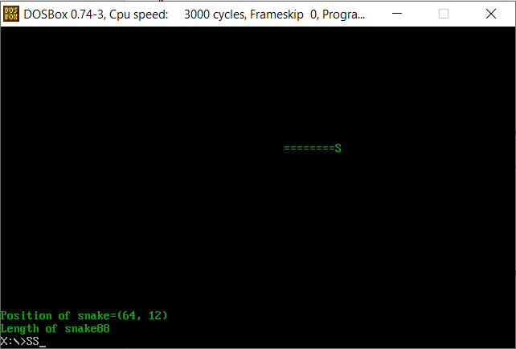

**Task 2:**

**Code:**

[org 0x0100]

jmp start

clearScreen:

push ax

push di

push es

mov ax, 0xb800

mov es, ax

mov di, 0

cls:

mov word[es:di], 0x0720

add di, 2

cmp di, 4000

jne cls

pop es

pop di

pop ax

ret

print:

push bp

mov bp, sp

push ax

push bx

push cx

push dx

push si

push di

push es

mov ax, 0xb800

mov es, ax

mov cx, 5 ;Rows = 5

mov bx, 4 ;spaces

mov dx, 1 ;Star = 1

mov di, 180

mov si, 10

l2:

add si, 158

mov di, si

push dx

l1:

mov al , '*'

mov ah, 0x07

mov WORD [es:di], ax

add di, 2

dec dx

cmp dx, 0

jne l1

pop dx

add dx, 2

loop l2

;180 * -190

;360 * -368

;540 *** -546

;720 ***

pop es

pop di

pop si

pop dx

pop cx

pop bx

pop ax

pop bp

ret

start:

call clearScreen

call print

mov ax, 0x4c00

int 21h

spaces dw 0

**Screen Shot:**

